Labour Market Report 2019

The Ministry of Welfare of the Republic of Latvia
September 2019
Riga

Table of contents:
1. INSTITUTIONAL FRAMEWORK 4
2. LABOUR MARKET SITUATION 8
2.1 Recent labour market developments 8
2.2. The profile of registered unemployed 11
2.3. Minimum wage and gross wage 11
2.4. Migration and labour market 12
2.5. Unemployment benefits and social assistance 14
3. ACTIVE LABOUR MARKET POLICY MEASURES 18
4. YOUTH GUARANTEE PROGRAMME AND THE PES 26
5. ACTIVE AGEING STRATEGY 30
6. LABOUR MARKET FORECASTING SYSTEM 34
7. SUPPORT TO SOCIAL ENTREPRENEURSHIP 36

Table of Annexes:
Annex 1: Employment and unemployment rate for those aged 15-64 (Eurostat, %) 38
Annex 2: Economic activity rate for those aged 15-64 (Eurostat, %) 38
Annex 3: Employed by economic activity (NACE Rev. 2.) (CSB, %) 39
Annex 4: Employed by age group (CSB, %) 40
Annex 5: Employed persons by the level of education (CSB, %) 40
Annex 6: Professional status of employed working in the main job (CSB, %) 41
Annex 7: Breakdown of employed persons by occupation (CSB, %) 41
Annex 8: Full-time and part-time employed (CSB, %) 42
Annex 9: Employed persons working part-time work because of inability to find full-time work (the share in the total number of working part-time) (CSB, %) 42
Annex 10: The minimum wage and the average monthly work remuneration by years (CSB) 42
Annex 11: Registered unemployment rate and number of unemployed (PES) 43
Annex 12: Breakdown of registered unemployed by length in unemployment (31.07.2018., PES) 44
Annex 13: Registered unemployed persons by education level (%) (PES) 44
Annex 14. Registered unemployed persons by risk groups at the end period (PES) 45
Annex 15: Main characteristics of registered unemployment (PES) 46
Annex 16: Participation in active labour market policy measures – new entrants (persons) in the corresponding year (PES) 47

INSTITUTIONAL FRAMEWORK

Law on Support for Unemployed Persons and Persons Seeking Employment (https://likumi.lv/ta/en/en/id/62539-support-for-unemployed-persons-and-persons-seeking-employment-law) determines the key functions of governmental institutions and municipalities in the implementation of active labour market policies (ALMPs).
Cross-sectoral cooperation and main documents for implementation of ALMPs and for activities aimed at reducing unemployment are listed below:
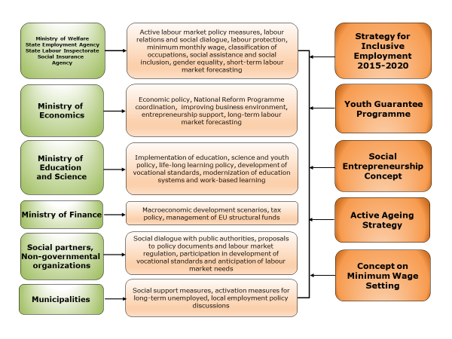
The State Employment Agency (www.nva.gov.lv) – Latvian Public Employment Service (hereinafter – PES) is the institution that is tasked with implementation of policies aimed at reducing unemployment including by providing efficient services and implementing measures for registered unemployed and other groups, in close co-operation with different partners, such as educational institutions, employers, non-governmental organizations (NGOs), social partners etc.
The policy documents in the field of employment can be found here - http://www.lm.gov.lv/eng/?option=com_content&view=article&layout=edit&id=82858.
Inclusive Employment Guidelines 2015-2020 (https://likumi.lv/ta/id/273969-par-ieklaujosas-nodarbinatibas-pamatnostadnem-2015-2020-gadam) is a medium-term policy planning document that determines policy objectives for the promotion of an inclusive labour market for the time period up to 2020. The objective of the Guidelines is to promote an inclusive labour market, enhance the labour market potential and to reduce the social consequences of unemployment, as well as to support the return of unemployed persons to the labour market and support a sustainable labour market integration particularly of those groups that are at risk of social exclusion.

The role of social partners in the design and implementation of ALMPs, cooperation mechanisms
National Tripartite Cooperation Council (NTCC) in Latvia coordinates and develops a tripartite social dialogue between employers’ organizations, the government and trade unions. Representatives from the government, Employers’ Confederation of Latvia (Latvijas Darba devēju konfederācija - LDDK) and Free Trade Union Confederation of Latvia (Latvijas Brīvo arodbiedrību savienība - LBAS) collaborate all together in NTCC as social partners.
The aim of the Council is to reach a consensus on different social and economic policy matters, to guarantee social stability during the implementation of the national reforms and to ensure an integrated way of decision making on socioeconomic development in compliance with the interests of the whole society. NTCC meets at least once in two months, and its work is regulated by the Statute of NTCC (adopted on 30.10.1998.). Agreements reached in NTCC are binding to all partners and information about meetings (agenda and protocols) is available online on the Cabinet of Ministers’ webpage.
NTCC has nine sub-councils:
- Budget and tax policy sub-council;
- Labour relations sub-council;
- Social security sub-council;
- Vocational education and employment sub-council;
- Healthcare sub-council;
- Transportation and communication sectoral sub-council;
- Environment protection sub-council;
- Regional development sub-council;
- Public security sub-council.
NTCC meetings are called and steered by the Prime Minister, an initiative for organizing a meeting may also come from the social partners. The State Chancellery is acting as the NTCC secretariat.
All questions related to Europe 2020 Strategy and European Semester, progress reports on Latvian National Reform Programme’s (NRP) implementation are discussed in the Cabinet of Ministers, Saeima (Parliament), with social partners, non-governmental organizations, representatives of the civil society, NTCC etc. This process includes all stages – planning, implementation and a yearly assessment of the progress achieved.
National progress reports on NRP implementation are discussed each year with social partners. The progress report is prepared in February-March each year (ministries, national agencies and other institutions submit information in writing to the Ministry of Economics). Then a meeting is organized with social partners by the Ministry of Economics to share and exchange views on information included in the progress report (the progress report is available to social partners before the meeting).
This process goes hand in hand with budgetary procedures of the state and evaluation of progress achieved in different economic and social fields in the previous year. Social partners are informed and are given the opportunity to intervene and express their opinions about reforms and policies being implemented, addressing labour market and social challenges – European Semester questions are integrated into work of several high-level working groups and councils. A separate discussion about prepared progress reports is taking place every year in spring. It is organized by the Ministry of Economics.
Council of Three Ministers on Employment (Minister for Economic, Minister for Education and Science, Minister for Welfare) meets regularly to ensure the implementation of balanced and mutually agreed policies in economic, welfare, employment, education and science fields. At the end of 2018, the work of the Council was strengthened by the establishment of a Council Steering Group at the level of the Ministries State Secretaries.
Vocational Education and Employment Tripartite Cooperation Council develops proposals for amendments in the regulatory framework regarding vocational education and training (VET) and also establishes a better link between the field of education and employment.
To ensure sector stakeholders’ involvement in VET and human resources development issues, 12 Sectoral Expert Councils (hereafter- SEC) had been established in Latvia in 2010. SEC meets at least once every two months, and they are governed by representatives from sectors. Sectoral Expert Councils consist of employers, employees and representatives from relevant ministries. SEC discuss the content of initial vocational education, enrolment of students in VET programs, sectors main professions and related professions and specializations, vocational qualification examination requirements, recognition procedures of competencies gained and other issues.
Unemployed Training Commission is governed by the Ministry of Welfare and meets regularly (at least once a year) to approve the list of training programmes for unemployed people and people seeking employment.
The Youth Guarantee Advisory Board (representatives from Free Trade Union Confederation of Latvia, Latvian Employers' Confederation, Latvian Association of Local and Regional Governments, National Youth Council of Latvia, the Ministry of Welfare, the Ministry of Education and Science, the PES, the State Education Development Agency and the Agency of International Programs for Youth) is responsible for coordination, implementation and evaluation of the Youth Guarantee measures and preparation of proposals for the necessary changes in the implementation process.
EU Structural Funds Monitoring Committee monitors the efficiency of finances allocated by EU funds’, assesses proposals for new EU fund’ activities and ensures broad discussions between sectoral ministries and social partners on new initiatives.

LABOUR MARKET SITUATION

2.1 Recent labour market developments

The population numbers in Latvia have been decreasing for a long time, in the period from 2000 to 2018 the decline was 447 thousands (decreasing on average by 0.4 – 0.5% per year). The main reasons are ageing of the society, low birth rates, and emigration of the population. At the beginning of 2019, there were 1 919 3968 permanent residents in Latvia, of whom 41% were aged 50 and over and only 9% aged 15-24.
Over the last 10 years, the labour market has changed profoundly. Within the age structure there is now a higher share of those aged 50 and over in the labour market and less young people entering, at the same time however with labour productivity being on an increasing trend.
The labour market situation has been improving over the last years. According to the results of the Labour force survey (LFS) labour market participation has increased to 77.7 per cent in 2018. The employment rate (for persons aged 15-64) has reached 71.8 per cent in 2018 (70.1 in 2017, 68.7 in 2016) and consequently there has been a decrease in both the LFS unemployment rate (for the persons aged 15-64) and the registered unemployment rate. The unemployment rate was 7,4% and the registered unemployment rate was 6.4 in 2018. The majority of the economically active population aged 15-64 years have gained higher (35.8%) and vocational (30.7%) education, although the proportion differs for men – 35,7% with vocational and 26,1% with tertiary education, and women – 25,8% with vocational and 45,6% with tertiary education. The share of the economically active population with secondary and lower education composed 33.3%. The number of economically inactive comprised 271.3 thousand or 22% of the total number of people aged 15-64 years.

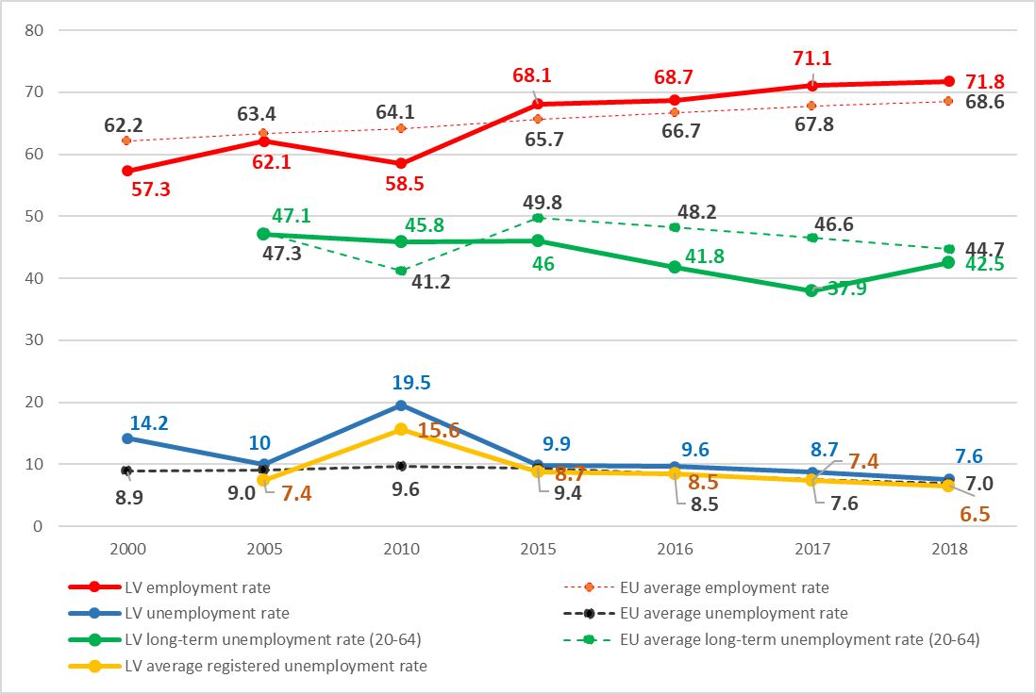
Figure 1: Employment rate and the unemployment rate in LV and EU, (15-64, %) (Eurostat)
In December 2018 the employment rate of 50+ in Latvia was 70.6%, which was 4.4 percentage points higher than the EU average (EUROSTAT).
According to Eurostat data, the unemployment rate has decreased considerably since 2010 but remains slightly above the European Union average (7.6% vs 6.5% in 2018) (Figure 1). Overall unemployment rate for women, however, is lower than for men in Latvia (6.4% and 8.4% accordingly in 2018).
At the end of 2018 the unemployment rate for the age group, 50-64 was 7.3% while the EU average unemployment rate was 5.2% (EUROSTAT)
The youth unemployment rate in Latvia, however, was among the highest in the European Union following the economic crisis after 2008 but it has fallen substantially in recent years, from 36.2% in 2010 to 12.2% in 2018 (3 percentage point lower than the EU average). Overall such a pattern suggests that continuous improvement in the labour market situation for youth is taking place, which is a result of improvements in the economy in general and several programmes implemented in Latvia to support youth employment.
The long-term unemployment rate (LTU rate) also continued to decrease in recent years reaching 3.1 in 2018 (0.2 percentage point higher than the EU average). The share of LTU in the total number of unemployed was 42.5% - 2.2 percentage points lower than the EU average.
In 2018 the vacancy rate for Latvia was 2,5% and was slightly above the European Union average – 2,2%. According to the PES information, the number of monthly registered vacancies in the PES database is increasing. In 2018, an average of 7 374 vacancies per month were registered (on average 5 945 in 2017 and 4 694 in 2016).

Figure 2: Registered unemployment (PES)
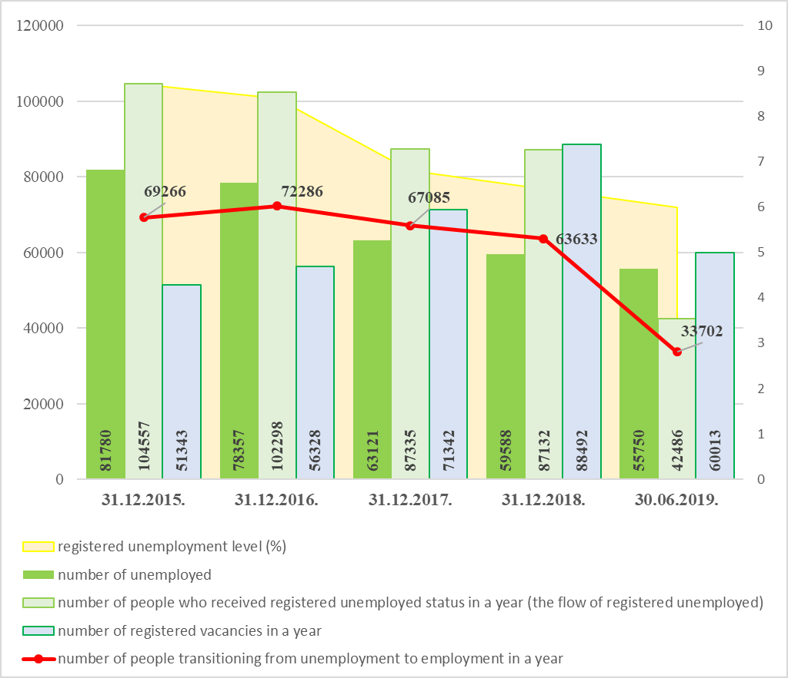
In June 2019, according to the PES data, the registered unemployment level in Latvia was 6.0%. At the regional level, unemployment rates vary across regions with the highest rate in Latgale region (14,1%) and lowest in the capital city of Latvia Riga (3,9%) and Riga region (4.1%).
At the end of June 2019, there were 55 750 unemployed persons registered at the PES.
The numbers of vacancies registered with the PES is increasing gradually. There were 88 492 job vacancies registered in PES in total in 2018 (71 342 vacancies in 2017).
Majority of jobs (even more so for job vacancies) are concentrated in the Riga region, less in urban centres in regions, but very few ones are in rural areas. Therefore, the access to jobs for the rural population can be considered as limited due to mainly relatively high transport costs, weak coverage of public transportation network and high resettlement costs for those who choose to move to urban centres or Riga.
In 2018, most vacancies (79%) were registered in major groups of medium-skilled occupations (retail sales assistants, lorry drivers, cooks, sales consultants, shop cashiers, carpenters, builders), followed by (12%) highly-skilled occupations (customer consultants, customer/sales consultants, software developers, sales managers, preschool teachers, nurses (medical nurses), project managers) and low-skilled occupations (9%) (auxiliary workers, cleaners, manufacturing labourers, label stickers, assemblers, shopping hall workers, construction workers, cargo handlers (manual work)). Compared to the previous year, the most significant increase of the number of vacancies can be observed in construction industry - builders, construction workers, building finishers, bricklayers, as well as in the transport and storage industry - truck drivers, auxiliary workers, loader jobs, metalworking machine operators.

2.2. The profile of registered unemployed
In December 2018 56% of all registered unemployed were women, and 44% were men.
Out of all registered unemployed, 43.4% is with primary or secondary education, 36.2% with vocational education and 20.4% with tertiary education in 2018.
The largest age group of registered unemployed is 55-59 years (16.8% of all unemployed). The share of unemployed aged 50 years and more comprises 40.5% and young unemployed aged 15-24 years – 5.8%.
The share of registered long-term unemployed in December 2018 was 25.1%. The largest group of registered long-term unemployed are persons aged 50 years and over – 59.6%.
Looking at the average characteristics of an unemployed person – it is a person without a profession, previously being in a profession with low qualifications required, in the age group of 50 years and above.
Most often redundancies are affecting low-skilled workers. In past years, the most significant number of unemployed were registered in the following occupations: hodman, shop assistant, cleaner, builder, driver, yard keeper, security guard, cook or a person without any profession. The most significant number of unemployed with higher education previously were working as engineer, economist, teacher, manager or the head of the company or unit, lawyer or an expert in personnel, public relations, logistics, design, environmental protection or bank sector.

2.3. Minimum wage and gross wage
There is a decentralised wage setting system in Latvia and one minimum wage level that is binding for all employers. As part of the Tax Reform the minimum monthly gross wage has been increased by 50 EUR thus reaching 430 EUR in 2018. In 2019, the minimum wage remained fixed at 430 EUR per month.
As from 2017, a few changes within the minimum wage setting framework has been put in place. Among others, it identifies additional indicators that have to be considered when elaborating possible changes to the minimum wage (e.g. productivity changes) and encompasses the requirement to discuss the proposal with social partners at the Social Security Sub-Council meeting before submitting to the National Tripartite Cooperation Council.
In addition to the national regulation on the minimum wage, social partners may specify other wage levels (including higher minimum wages) in company or industry level collective agreements, upon fulfilment of specific criteria industry level collective agreements can be extended to all the sector. According to the principle of labour rights that a collective agreement may not impair the status of an employee in comparison with laws and regulations (Section 6 of the Labour Law), thus only a higher wage and better working conditions may be specified in collective agreements.
Figure 3: Minimum monthly wage and gross mothly wage (EUR)
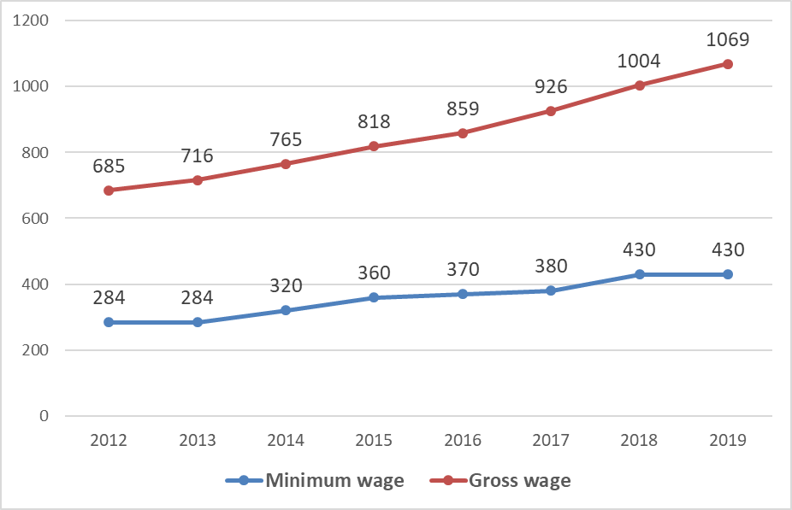
When comparing the proportion of the minimum monthly wage to the average monthly gross work remuneration of employees for the previous year calculated by the Central Statistical Bureau (hereinafter – CSB), it may be concluded that starting from 2016 the amount of the minimum monthly wage decreases as a percentage in relation to the average monthly gross work remuneration of employees for the previous year calculated by the CSB (see Annex 10).

2.4. Migration and labour market

According to data of the Office of Citizenship and Migration Affairs (hereinafter – OCMA), on 31 December 2018, there were more than 95 thousand foreigners living in Latvia, out of whom 77 069 were third-country nationals – 48 295 with a permanent residence permit and 28 774 with a temporary residence permit.
According to the national regulation on employment of foreigners if an employer is intending to employ a foreigner (a third-country national) by entering into an employment contract, it should register a vacancy at the PES. It should be vacant for not less than a month after registration until the day when the employer turns to the OCMA in order to confirm an invitation for requesting a visa or a sponsorship for requesting a residence permit for a foreigner. According to OCMA’s statistics, over the last years, the number of third-country nationals coming to Latvia (mainly from Ukraine, Belarus and Russia) with a purpose of employment has increased: 11 359 rights to employment were granted in 2018 (7 688 rights in 2017, 6 007 in 2016, 4 808- in 2015). Most of the guest workers are employed in the field of land transport and pipeline transport, building construction, computer programming and consultancy, non-metallic mineral products, catering services as well as specialized construction.
In 2018 the government has adopted a list of 237 professions where currently there is a risk of the insufficient labour force and where reliefs for the attraction of highly qualified specialists apply. For example, for EU Blue Card applicants the minimum salary shall not be below the average gross wage in Latvia in the previous year, multiplied by coefficient 1,2 (instead of the previous coefficient 1,5). In other cases – a foreigner could be attracted for the vacant position that is registered at the PES for at least 10 working days, instead of the previous requirement – at least for a month.
The PES support measures, including career guidance consultations and Latvian language for unemployed persons and job seekers, are available to various categories of foreign nationals, along with Latvian nationals, as provided by the Law on Support for Unemployed Persons and Persons Seeking Employment. According to PES data, 1 594 foreign nationals, both from EU/EEA and Switzerland and the third countries, were registered at PES as unemployed or job seekers at the end of 2018.
Information about working and living conditions and vacancies can also be obtained on the European Job Mobility Portal of European Employment Services (EURES) and is also provided by EURES consultants at the PES. Main objectives of EURES is to inform, guide and provide advice to potentially mobile workers on job opportunities as well as living and working conditions in the European Economic Area, to assist employers wishing to recruit workers from other countries and to provide advice and guidance to workers and employers in cross-border regions. Information about job opportunities abroad, living and working conditions is also available at the PES website (http://www.nva.gov.lv/eures/). Third-country nationals are also provided with information, including legal consultations, on work opportunities, at the Information centre for newcomers and a website www.integration.lv, managed by a non-governmental organization “Safe House” in the framework of a project co-funded under the Asylum, Migration and Integration Fund.
Following the adoption of the Action Plan for Relocation and Reception of Persons in Need of International Protection at the end of 2015, the PES has been implementing a project aiming at improving employment prospects for asylum seekers, refugees and persons with alternative status (subsidiary protection) and their social and economic inclusion. In addition to active labour market measures offered to refugees and persons with alternative status, asylum seekers are offered an introductory course “Work opportunities in Latvia” and consultations on work opportunities in the Reception centre for asylum seekers “Mucenieki”. There is also an e-leaflet “First steps to employment” including information on work, education, housing and social support available in 5 languages (https://begluintegracija.nva.gov.lv/en/). The PES has developed cooperation with more than 126 employers who would like to hire refugees and persons with alternative status. During the time period from 1 January 2016 until 31 May 2019, the PES has registered 172 refugees, and persons with alternative status (many of them repeatedly), 17 refugees or persons with alternative status were in the register at the end of May 2019. Since 2016, 59 refugees or persons with alternative status have found a job with the assistance of the PES (40 of them still working – in supermarkets, storehouses, woodworking etc.) (PES data 31.05.2019.).

2.5. Unemployment benefits and social assistance

Persons eligible for acquiring the status of an unemployed person after registering in PES are:
- unemployed (not considered an employee or a self-employed person in compliance with the Law on State Social Insurance);
- seeking a job;
- able to work and ready to become employed immediately;
- at least 15 years old;
- below the age that gives the right to receive the State old age pension or has not been granted the pension (including early retirement);
- not admitted to a full-time primary or secondary education programme;
- not performing commercial activities or whose commercial activities have been suspended in compliance with the normative acts;
- not in custody and do not receive long-term social care or social rehabilitation services under State or municipality support.

Unemployed persons can register in any Local Employment Office of PES regardless of the declared address.
Accordingly to the Support for Unemployed Persons and Persons Seeking Employment Law active seeking of employment is the purposeful activities of a person with the intention to find paid employment – participation in competitions for available vacancies and other activities with the purpose of finding employment.
Considering the improving labour market conditions the sanction regime for unemployment benefit recipients has been adjusted to activate and foster the return of the unemployed into the labour market. The criteria for setting a suitable job are defined and stricter conditions for acceptance of a job offer for unemployed persons after six months unemployment spell.

Unemployment benefit can be received after a person has registered in PES and acquired the status of an unemployed person:
- if social insurance contributions overall were made for (work tenure) not less than one year and social insurance contributions before the acquisition of the status of unemployed person were made or had to be made not less than for 12 months out of last 16 months period before the acquisition of the status of the unemployed;
- mother or another person (father, custodian) who has raised the child up to 1.5 years of age and received the parental benefit or child care benefit;
- persons who received sickness benefit;
- persons who have received compensation for the care of the child to be adopted;
- if the person was disabled or was taking care of a disabled child up to 18 years of age.
An unemployed person cannot combine unemployment benefit with part-time or temporary employment. An unemployed person is allowed to work (as employees or self-employed persons) for the period that does not exceed two months without losing the status of registered unemployed. However, the unemployment benefits are not paid for such periods.
An unemployed person may receive the dividends as owners or shareholders of enterprises.
Unemployment benefit shall be calculated in proportion to the total length of the insurance (employment) record and in accordance with the income from which unemployment contributions have been paid:
The length of the insurance (employment) record: | The amount of the benefit granted:
from 1 to 9 years (included) | 50% of the average contributions salary
from 10 to 19 years (included) | 55% of the average contributions salary
from 20 to 29 years (included) | 60% of the average contributions salary
30 years or more | 65% of the average contributions salary

If, before acquiring the status of the unemployed, unemployed person raised a child under the age of eighteen months and received the child care benefit, have been disabled and have regained working ability and has taken care of a disabled child until he/she turned 18, the unemployment benefit shall be granted in the amount of 60% of the double amount of the state social security benefit per month for the first three months (the state social security benefit is 84,06 EUR in 2018), after that the amount of the unemployment benefit is reduced – for the following three months the benefit is 75% of the benefit amount granted, and for the last three months – 50% of the benefit amount granted).

The maximum term of payment of the unemployment benefit has been set to nine months for all unemployed persons and depending on the term of unemployment the following amounts of the benefit are paid:
- during the first three months - the full amount of the granted unemployment benefit,
- during the next three months - 75 per cent of the granted unemployment benefit,
- during the last three months - 50 per cent of the granted unemployment benefit.
An unemployed person is obliged to:
- actively seek employment both individually and with the assistance of PES, and provide proposals for the development of individual job search plan immediately after acquiring the unemployed person status;
- attend PES on the day specified in the individual job search plan and present the documents stated in the normative acts;
- attend PES within three working days from receiving the invitation;
- participate in the measures included in the individual job search plan;
- inform PES:
- within one working day if they no longer comply with the following conditions stated in the first part of Article 10 of the Support for Unemployed Persons and Persons Seeking Employment Law: is unemployed (not considered an employee or a self-employed person in compliance with the Law on State Social Insurance); is able to work and ready to become employed immediately; has not reached the age that gives the right to receive the State old age pension or has not been granted the pension (including early retirement); is not admitted to a full-time primary or secondary education programme; is not performing commercial activities or whose commercial activities have been suspended in compliance with the normative acts; is not under full support by State,
- within one working day if they have acquired employee status for a period up to two months in accordance with the Law on State Social Insurance,
- within three weeks from the beginning of a temporary work disability – of the period of temporary work disability if it has been longer than ten days.

Social assistance and unemployment status
In order to get social assistance from municipal social services a person of working age must register at PES and actively look for a job. Registration at PES is not mandatory for recipients of invalidity pensions, persons during child care leave, persons above 15 years of age who are studying, one of the parents who have a child with disabilities.
In order to improve coverage of social assistance benefits and to introduce additional incentives to motivate the beneficiaries of social assistance to get a paid job, the Amendments to the Law on Social Services and Social Assistance came into force as of 9 February 2017, allowing a gradual phase-out of social assistance benefits three months after starting employment (to the extent of the monthly minimum wage).

ACTIVE LABOUR MARKET POLICY MEASURES

(ALMP measures)

Taking into account the consequences of the global financial crisis and impact of implemented structural adjustments on the labour market during the last years, there was a need for both types of measures – short-term measures, aimed at alleviating the severe social consequences of the crisis and reducing the risk of increasing poverty (emergency public works programme, complex inclusion measures, training for employed with reduced working hours) and long-term measures, aimed at enhancing the labour force competitiveness and giving positive signals to unemployed and other people in general enhancing labour competitiveness and to promote the inclusion of disadvantaged groups into the labour market

The Public Employment Service (PES) of Latvia provides assistance to the unemployed, job seekers and people at risk of unemployment to promote their competitiveness in the labour market according to their needs, abilities and implements and administers active labour market policy (ALMP) measures for unemployment reduction.
Additionally, among other functions, the PES registers and informs about the vacancies, organizes cooperation and information exchange between employers and unemployed persons, provides consultation on the occupational suitability, selection of an appropriate occupation and vocational training, issues licences and supervises work placement service providers etc.
Involvement of registered unemployed in ALMP measures is based on individual approach, a profiling system is used to choose the most suitable support measures and unique path to the labour market for each unemployed.
General provisions of ALMP implementation are stated in the Regulations of the Cabinet of Ministers No. 75 (adopted on 25th of January 2011) - Regulations Regarding the Procedures for Organising and Financing of Active Employment Measures and Preventative Measures for Unemployment Reduction and Principles for Selection of Implementers of Measures.

- JOB SEARCH ASSISTANCE AND GUIDANCE
Profiling and individual job search plan:
In order to identify needs of the unemployed, a profiling system has been developed with the aim to shorten the period of unemployment and prevent potential risks that could delay return in the labour market by providing most appropriate measures and intensity. As a result of profiling, an individual job search plan is prepared, and persons are involved in the most suitable measures sequenced in a way that would ensure the most effective labour market outcome based on job opportunities by demographic characteristics, self-esteem and motivation to look for a job and cooperate with the PES.

Informative days:
Informative days are organised by the PES with the aim to provide information about the available services, as well as informative support in the process of seeking employment. Unemployed receive informative materials about PES services, presentation materials, samples for writing resume and letter of application etc. Informative days are held in all PES Local Employment Offices at least once a week.

Career guidance consultations:
Career guidance consultations are aimed at providing assistance to the unemployed, job seekers and people at risk of unemployment in determining professional compatibility, planning career and retraining. The services provided individually or in groups include consultations on choosing education and career, vocational development, returning to the labour market and changing occupations, assessment of client’s vocational aptitude, interests and preferences, abilities, skills and suitability for a given profession, consultations about effective ways of job search, provision of information about the content and requirements of different occupations, information about educational and training opportunities in Latvia and abroad.

PES portal of CV and Vacancies:
PES portal of CV and Vacancies is the largest vacancy database in Latvia covering all districts of Latvia, where job seekers can register their CV and search for available vacancies by various parameters. At the same time, employers can register their vacancies and search the necessary employees. Additionally, assistance in personnel selection is provided by the PES.

- TRAINING PROGRAMMES
Measures to Increase Competitiveness (basic competencies):
Measures to Increase Competitiveness (MIC) are aimed to promote the competitiveness of the unemployed, job seekers and people at risk of unemployment in the labour market. MIC include individual consultations and group lessons (5-36 acad. hours courses, seminars, lectures) for psychological support, acquiring job seeking methods and the necessary abilities and skills demanded in labour market, e.g. CV writing, job-finding and interview skills, communications skills, networking, negotiation, motivation etc.
Vocational training and non-formal training programmes:
Vocational training and non-formal training programmes are organized by the PES in co-operation with educational institutions and employers only for registered unemployed and job-seekers.
Since 2011, all the training programmes are implemented by applying a method of training vouchers. Training fields and educational programmes are organized in accordance with the labour market demand and national economic development forecasts and agreed with economic and social partners and experts at National Commission for defining the training fields and approving the training programmes.
The length of training programmes may vary:
  - from 60 to 160 hours for non-formal training programmes (the value of a voucher does not exceed 360 EUR or 520 – 670 EUR for specific driving courses);
  - from 160 to 320 hours for advanced vocational training to reach vocational proficiency (the value of a voucher does not exceed 400 EUR);
  - from 480 to 1280 hours for vocational training programmes (the value of a voucher does not exceed 600 EUR for programmes with 480 hours, 800 EUR for programmes with 640 hours, 1220 EUR for programmes with 960 - 1280 hours).
Participation in programmes may last up to 6 months – full -day participation (8 hours) is usually applied. Simple or low-skilled occupations are excluded from the list of training programmes. An unemployed person may participate in vocational training programmes once in a two-year period and in non-formal programmes not more often than twice a year, except State language courses where a person may be involved in the acquisition of no more than three education programmes.
Participants are also receiving financial support during training - 5 EUR day stipend. The following additional expenses are also covered by the PES: training place adaptation for persons with disabilities, the involvement of care personnel for persons with disabilities such as assistants, silent language experts etc. and other related expenses.
If an unemployed person interrupts participation with no valid reason, he/she must cover the expenses that occurred to the PES for a training programme.

On-the-job training:
Training at the employer is organised to prepare a specialist demanded by the employer. Within the measure acquisition of a new profession can be organised that lasts in total for up to six months. This training is organized only for the registered unemployed.
The PES in co-operation with employers carries out the selection of unemployed persons to be involved in the practical training in conformity with the qualification requirements stated by the employer. The suitability of a person is determined by the employer.
The employer is obliged to employ a person starting with the first day of practical training and at least 3 months after the practical training is finished. The employer must pay at least a monthly minimum wage for a person. If these criteria are not met, the employer must cover the expenses of practical training to the PES. An unemployed person may be involved in such kind of training only once in a two-year period.
The PES covers a part of a salary paid to the unemployed (in a declining amount to reflect productivity increases): first three months of practical training – 200 EUR, second three months – 150 EUR.
The employer shall ensure:
  - the renewal of work skills and professional abilities or the acquisition of a new profession by organising the necessary theoretical and practical training and by providing the necessary knowledge regarding the professional duties and the basic requirements related to the fulfilment thereof;
  - a qualified supervisor, who shall help a person to strengthen the work skills, professional abilities and knowledge (the PES covers subsidy to a qualified work manager in the amount of 50% of a monthly minimum wage);
  - the ability to carry out the relevant professional obligations and basic tasks after the completion of the practical training.
The PES covers additional expenses related to the adaptation of a workplace for a person with disabilities not exceeding 711 EUR per workplace. Expenses for health examinations (up to 30 EUR) and individual protective equipment (if appropriate) up to 100 EUR can also be covered by the PES.

- EMPLOYMENT PROGRAMMES
Subsidised employment for the most vulnerable groups of unemployed:
Measures for the most vulnerable groups are aimed at helping the unemployed understand labour market requirements and promote the unemployed person inclusion in society and settling in the permanent job by employing unemployed persons in subsidised jobs. The target group of the measure are persons with disabilities, long-term unemployed, refugees and persons with alternative status and persons aged 55 years and more.
The employer may be a private company (with the exception of medical institutions and education establishments implementing educational programmes), self-employed persons, societies or foundations (with the exception of political parties).
Employer provides a qualified work supervisor for each participating unemployed person that assists the unemployed person in acquiring the basic skills and abilities required for work (the involvement of the supervisor may be different and depends on the complexity of work to be done, unemployed person profile (more extended involvement in the case of persons with disabilities and young unemployed) and other characteristics).
The financial support for employing unemployed persons is granted for a period up to 12 months (for unemployed at least for 12 months, for 55+ and for refugees and persons with alternative status), up to 24 months (for disabled unemployed). Support includes monthly wage subsidy for an unemployed person which equals 50% of the total wage costs, but it cannot exceed the minimum monthly wage set by the government (430 EUR in 2019). If the employer employs a person with disabilities, monthly wage subsidy cannot exceed 1,5 minimum monthly wage and equals to the minimum monthly wage if the employer provides workplace requiring low qualification.
Additional expenses for work supervisors, working place adaptation for persons with disabilities, the involvement of different experts, such as assistants, silent language experts etc. are covered by the PES.

Paid temporary public works:
Paid temporary public work is an active labour market measure for unemployed persons to acquire and maintain work skills by performing socially beneficial work. Paid temporary public work is offered by municipalities, societies or foundations without the intention of gaining profit.
Main features of public works in Latvia are the following:
  - The measure targets exclusively the long-term unemployed who have been registered with the PES as unemployed for longer than 6 months or have been registered as unemployed for less than 6 months but have been without employment for at least 12 months. Besides, in order to be eligible for participation in the activity, the unemployed person shall not receive unemployment benefit or old-age pension.
  - The jobs are non-commercial activities in areas that are additional to tasks currently carried out by the local governments. A list of indicative jobs to be carried out by the unemployed is as follows:
    - cleaning and improvement of municipal territories (parks, streets, municipal buildings, tourism areas etc.),
    - improvement of graveyard territories,
    - repairs of municipal buildings and communications,
    - cleaning and improvement of roadsides,
    - preparation of firewood,
    - auxiliary works in the social care sector,
    - auxiliary works in municipal institutions (schools, kindergartens, libraries, cultural centres etc.).
  - Substitution of workers is prohibited. Workplaces should be newly created, or they have to be vacant for at least a period of 4 months. Besides, the unemployed can not have previous work experience in the body providing a workplace (at least for 12 months before participation in the activity).
  - The period of participation in the activity by the long-term unemployed will not exceed 4 months per year (may not exceed 6 months if participant has reached 60 years of age). Participants can have 2 days per month off to actively search for a job under the guidance of the PES or individually having an obligation to inform the PES on results of a job-search process. These 2 days can also be used for participation in the PES short-term measures, like individual counselling, group sessions on job search methods and basic skills needed in the labour market.
  - Daily temporary public work may not exceed 6 hours. For performing paid temporary public work the unemployed person receives a monthly remuneration of 200 EUR. In addition, social insurance contributions are made for them to cover the pension insurance and participants are insured against accidents at work. Expenses for mandatory health checks are covered for participants of the programme. Monthly subsidy for one paid temporary public work coordinator in the municipality is paid in an amount of 150 EUR depending on the days of actual employment.

Entrepreneurship and self-employment:
Measures to facilitate start-up of business activities and self-employment are aimed at providing consultative and financial support helping unemployed persons with the appropriate skills and motivation to start business activities or self-employment and successfully work in the chosen field at least 2 years.
Support is provided to unemployed with appropriate level of knowledge - who have gained a sufficient level of education or completed vocational training or non-formal education programmes in the PES (different training courses in business administration, for example, basics of business administration, project management, business plan developing, accounting and finance, marketing and basic management etc.).
The measure includes consultations on developing and implementing a business plan, business grant up to 5000 EUR depending on the approved budget estimate and monthly subsidies for the first six months of business plan implementation in the amount of minimum monthly wage.

- OTHER MEASURES
Measures aimed at long-term unemployed with addiction problems:
Support measures for the unemployed with addiction problems are aimed to treat the dependence on alcohol, narcotic or psychotropic drugs through Minnesota 12 Step Programme (28 -day treatment), thus promoting a sooner entrance in the labour market. The target group of the measure are unemployed persons (at least 3-6 months) that have received a narcologist’s conclusion for alcohol, narcotic or psychotropic drug dependence.
Promotion of regional mobility:
The regional mobility support is available to unemployed who start employment at least 15 km far from a declared residence place.
The regional mobility support for covering transportation or living costs is available also in various labour market policy measures - in subsidized employment and for training if working place or training institution is at least 15 km far from a declared residence place. An amount of support depends on real costs of transportation or living - a person shall submit to PES all documents justifying expenses. The maximum amount of support is up to 150 EUR per month for all training period or for first 4 months if a person starts labour relations (both, normal ones or subsidized by the PES).

Activation programme for the long -term unemployed:
The aim of the programme is to improve the effectiveness and targeting of ALMPS programmes, reaching out for those at the margins of the labour market.

The following support is provided within the measure:
  - Individual and group consultations (incl. career consultations, psychological and psychotherapeutic support).
  - In-depth health checks to assess suitability for the possible job opportunities, covering laboratory and functional costs and also transport costs to/from the doctor.
  - Assessment of professional suitability for persons with disability or health problems to be provided by State Social Integration Agency within special 10 days programme.
  - Motivational programmes – provided by outsourced service providers. The service provider has to ensure psychological support, motivation measures, support and consultation to provide help for solving social problems. The service provider has to provide the service individually or in the group (max 12 persons). The service provider has to ensure meals and transportation of participants during the motivation course. After completion of motivation programme the mentor has to be provided (the person that helps in job-search activities and provides psychologic support, one mentor for max 6 persons) for up to three months (for disabled unemployed – seven months).

Funding
Although public expenditures on labour market policies stay below 1% of GDP, however, this expenditure has been growing since 2012 and has reached 0.639% in 2016. In 2012 109.6 million euro were allocated to labour market policies (including unemployment benefits), in 2016 – 160 million euro. It constitutes a budget increase of 46% in the past five years, while the average number of registered unemployed decreased by 24.7%.
Year | 2005 | 2006 | 2007 | 2008 | 2009 | 2010 | 2011 | 2012 | 2013 | 2014 | 2015 | 2016
% of GDP | 0.508 | 0.507 | 0.427 | 0.453 | 1.328 | 1.259 | 0.694 | 0.497 | 0.552 | 0.549 | 0.556 | 0.639

Involvement of registered unemployed in ALMPs is based on an individual approach, and a profiling system is used to set the most suitable measures in such a sequence as to ensure a fast and sustainable integration into the labour market. The coverage rate of unemployed with PES services remains rather high – according to LFS data, in 2017 on average 74% out of all unemployed were registered in PES (63.1 out of 85.4 thousand). According to PES data, in 2017 on average 106 thousand unemployed or 64% of all registered unemployed (inflow figures into unemployment) participated in at least one PES measure.

YOUTH GUARANTEE PROGRAMME AND THE PES

Youth Guarantee programme in Latvia is being implemented since the beginning of 2014. The aim of the Youth Guarantee is to establish a long-term and comprehensive approach on timely activation of young people, by providing job-search support, employment and training measures or returning into an education system.
Since the beginning of 2019 changes were introduced in the programme regarding provision of support to registered young unemployed in PES, as a consequence of a rapidly decreasing number of young people not in education or employment (NEETs).
The Youth Guarantee programme in Latvia is co-financed by the EU Youth Employment Initiative and is being implemented within the Operational Programme „Human Resources and Employment” specific objective No 7.2.1. “To increase employment of young people not in employment, education or training and to facilitate their participation in education within the framework of the Youth Guarantee” (hereafter – YG) and No 8.3.3. “To develop skills of young NEETs, not registered in the PES”. Within the YG three national projects are being implemented since the beginning of 2014 – the PES project “Active labour market policy measures for unemployed young people” (finished at the end of 2018), the State Education development agency’s (SEDA) project “Implementation of vocational education programs for young people not in employment and training” and the Agency’s for International Programmes for Youth (AIPY) project “Know and Do!”.
Funding of EUR 63.4 million is foreseen for the three stages of the YG over the period from 2014 to 2020.
In 2014 a model of cooperation was established between the Ministry of Welfare, the Ministry of Education and Science, PES, SEDA, AIPY, schools, municipalities, social services and NGOs. Agreements for cooperation were signed between both ministries, PES and SEDA, PES and AIPY, AIPY and municipalities. Educational institutions, employers, NGOs signed contracts with SEDA, PES and AIPY for the provision of targeted services to young NEETs.
The upscaling and sustainability of partnerships is ensured through The Youth Guarantee Advisory Board and EU funds Monitoring Committee. The Monitoring Committee is chaired by the Head of Managing Authority and consists of representatives from the Managing Authority, Responsible Institutions, Co-operation Institutions, Paying Authority, Audit Authority, Certifying Authority, as well as social partners, non-governmental sector and regional partners.
Additionally, The Youth Guarantee Advisory Board is analysing the progress achieved in the implementation of YG on a regular basis (it meets at least once a year), involving representatives of social partners, Latvian Association of Local and Regional Governments, National Youth Council of Latvia, governmental institutions, local governments, regional development agencies etc. Therefore, the YG have both types of partnerships – policy and project-based.
Each year the Ministry of Welfare prepares the report on YG implementation progress. This report assesses the current situation of young people on the labour market and indicates all obstacles in the implementation of three projects. This report is then submitted for discussion in the Youth Guarantee Advisory Board, and opinion of different partners is included into the report and amendments (if needed) are being made in the national regulative acts on the implementation of the YG.
The YG measures are also aimed at young people, facing multiple barriers to the labour market. For example, specialized services are available for young people with disabilities (additional support for attracting work supervisors, work or education place adaptation, the involvement of different experts, such as assistants, silent language experts etc.).
Statistics provided by the YG projects shows that on average 50% - 55% of all young people receive an offer and start participation in employment or education measures or enter employment within the first four months after entering the YG. On average 30% of young people stay in the YG for longer than four months, and particular worries call another 20% of all young people, who interrupt participation in the YG before receiving an offer.
It should also be admitted that gathering statistical data is sometimes limited, for example, for a part of young people who leave the YG earlier and particularly for assessment of the overall number of NEETs in the country and how many out of them find their own route to the labour market or further education without intervention from the policy side.
The evaluation of YG training programmes was carried out in 2017 by the European Commission’s Joint Research Centre in collaboration with the Ministry of Finance and the Ministry of Welfare. The study found positive, although not statistically significant evidence that participating in the training course increased the employment probability for the participants (comparing to the target group).
The Ministry of Finance conducted a wide study on the YG programme results and impact in 2018-2019. According to the study (see Footnote, pages 15-17), YG support activities purposefully promote faster return of young people to the labor market - a positive impact of intervention during the year since the end date of participation on the share of newly employed or newly self-employed can be observed in almost all activities - in the short term (6 and 12 months) and in the medium term (18 months), a positive impact of intervention on job placement has been observed in further vocational education and vocational development programs (including thematic groups “Entrepreneurship, finance, accounting, administration (wholesale, retail and commercial science)”, “Energy” and “Metalworking and Mechanical Engineering”), among learners of foreign languages, participants in “Training for drivers of vehicles and tractors” and in initial vocational training programs (including thematic group “Entrepreneurship, finance, accounting, administration (wholesale, retail and commercial science)”). In the short term, job placement has also been facilitated by participation in the “Development of skills necessary for work in the non-governmental sector”.
PES support to young NEETs
At the PES special workers who work with young people in local affiliates are assigned. A career consultant is following a young person’s achievements in measures and interacts if something is not working properly (for example, if a young person stops attending lectures, seminars etc.). Each young person may have several meetings with a career consultant at the PES if necessary.
Support provided to young people includes (see description of measures above):
- Profiling, job-search assistance, career counselling, development of basic competencies;
  - Non-formal training programmes;
  - Vocational education programmes;
  - First work experience for youth in NGOs:
Considering the limited amount of newly created workplaces and realizing that not all companies are able to provide work experience schemes to young people, an additional measure is aimed at supporting the acquiring of basic working skills in non-governmental organizations. Both work experience measures are monitored and supervised to increase or limit their scale in conformity with changes in the labour market (the increase or decrease in the number of newly available jobs, the results of “Dual VET” pilot project). The aim is to give an opportunity to gain work experience for up to 6 months in NGOs. Within the measure, a young person receives a daily stipend – 5 EUR.
  - Subsidized workplaces;
  - Measures to support entering self-employment or entrepreneurship.

The State Education Development Agency’s (SEDA) project “Implementation of vocational education programs for young people not in employment and training”
The aim of the measure is to provide support for those young people who have left school or training without achieving qualification and who have not succeeded in the labour market. Vocational education programmes with length 1 or 1.5 years are provided (2nd and 3rd level vocational qualifications). Programmes are implemented either as work -based learning or with a traineeship in company component. Provision of training programmes for imprisoned youth (15-29 years) is also foreseen. On average 2 000 young NEETs, not registered at the PES, start participation in SEDA project each year.

The Agency’s for International Programmes for Youth (AIPY) project “Know and Do!”
The AIPY national project “Know and Do!” is aimed at outreaching young NEETs not registered at the PES and not participating in the SEDA project. It started in September 2015. It is being implemented in close collaboration with Latvian local governments (municipalities should establish partnerships with local NGOs and Youth organizations in order to be able to participate in a project). The expected number of participants – at least 5 300 young persons in 2015-2018 (the average number of young NEETs (15-24 years) in 2nd quarter 2017 was 18.7 thousand, approximately 40% of all NEETs are registered as unemployed at the PES.
The aim of the project is to motivate and activate young persons, to foster their involvement in the educational system, labour market, promote activities of the youth centres or NGOs. It includes outreach and information activities, profiling of young persons and the individual support programme with measures which include four components (based on the UNESCO Four Pillars of Education): lifelong learning competencies (learning to know); social inclusion (learning to live together); development of personality (learning to be); working virtue (learning to do). A mentor is assigned to work and support each young person (a mentor can be a social worker, a person, working in NGO, a young person etc.).
In order to foster cooperation between different actors on early leavers, new ESF co-funded project was launched in 2016 “Reduce early school leaving through preventive and intervention measures”. This project together with the YG project “Know and Do!” is aimed at establishing the permanent mechanism of early intervention and successful exchange of information between different partners in a case, when a young person is experiencing difficulties and is dropping out from the education process. Within the project “Work and Do!” new communication strategies are tested, for example, with probation services and police, to help also young people with behavioural problems to integrate into education system or employment.

ACTIVE AGEING STRATEGY

The labour market age structure has changed considerably in Latvia if compared to 10 years ago – with those in higher ages continuing to contribute to the economy. This has increasingly led to changing attitudes. However, stereotypes are something that still needs to be tackled.
The current demographic situation in Latvia indicates ageing and depopulation trends, especially between the working-age population, which stresses the importance of efficient use of the existing labour force potential.
Latvia is ranked 16th out of all 28 EU Member States in the 2018 UNECE Active Ageing Index (AAI) , calculated for EU countries on the basis of the latest available data (2016) (19th out of all 28 EU Member States in the 2014), which measures the experience of individuals aged 50 and over (50+) in terms of employment, social participation, independent living and capacity for Active Ageing (e.g. health status, engagement in lifelong learning):
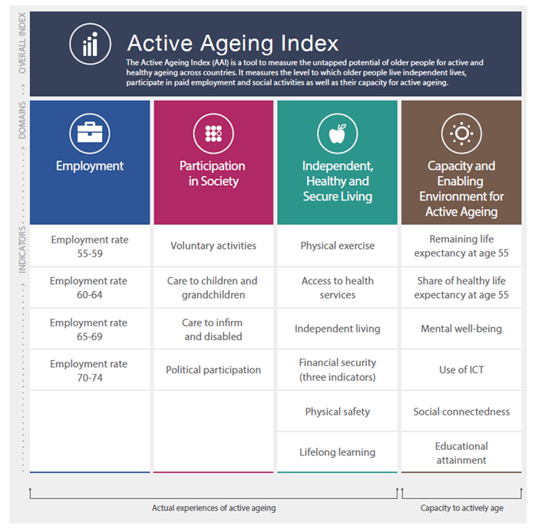

  - On the employment sub-index, Latvia ranks 6th and participatition in society sub-index – 13th.
– The results in such area as independent, healthy and secure living are significantly lower with Latvia being the worst performer among the EU member states.
– Latvia ranks 23rd in AAI’s capacity and enabling environment for Active Ageing, where the most significant emphasis is on such indicators as remaining and healthy life expectancy at age 55.
Latvia is in the process of increasing the statutory retirement age (SRA). The standard (legal) retirement age for men and women, starting from 2014, increases gradually from 62 years by 3 months per year, until reaching 65 years in 2025 (SRA in 2019- 63 years and 6 months both for men and women). Interestingly, according to operational data, the insurance record for women is currently longer than for men (around 2 years difference). Increase in the statutory retirement age leads to more extended labour market participation.
In 2014-2016 (from March 2014 to February 2016) with the support of the European Union, the Ministry of Welfare implemented a project on Active Ageing “Latvia: Developing a Comprehensive Active Ageing Strategy for Longer and Better Working Lives”. The objective of the project was to develop an evidence-based and comprehensive Active Ageing Strategy in Latvia that would facilitate longer and better - working lives, taking into account the considerable demographic challenges that the country is currently facing.
Within this project, the World Bank carried out a study “The Active Aging Challenge for Longer Working Lives in Latvia” and gave recommendations for the improvements in the Active Ageing situation and for developing an Active Ageing Strategy.
The World Bank worked in close cooperation with the project steering committee, which assessed the Active Ageing study's recommendations and developed proposals for the Active Ageing Strategy. The steering committee was formed of representatives from ministries and public institutions, which responsibilities are related to Active Ageing issues, as well as social partners thus ensuring a comprehensive approach.
The Ministry of Welfare formed a strategic partnership with the Austrian Federal Ministry for Labour and Social Affairs and Consumer Protection, Ministry of Labour and Social Policy of Poland and Ministry of Social Affairs of the Republic of Estonia in order to exchange good practices and experience during study visits and seminars. Seminars covered general Active Ageing issues as well as specific topics, such as employment, health, social security and care for family members with the participation of representatives of ministries and institutions, international organizations and non-governmental sector.
As a result, a conceptual report “Active Ageing Strategy for longer and better working lives in Latvia” was prepared after holding these discussions. The conceptual report was adopted by the Cabinet of Ministers on 6 September 2016. Target group covered by the measures was set as older people aged 50+, especially till retirement age, who face significant barriers to enter the labour market.
The following priorities were set:
– Employment: inclusive labour market for older people;
– Education: educated and knowledgeable older workers responding to changing labour market conditions;
– Health: healthy and physically active older people, who can remain active and independent for as long as possible;
– Social protection: socially protected older workers.
The conceptual report presented a solution to improve the situation of Active Ageing in the country, the aim of which is to promote longer and better working lives of Latvia's population and to improve the overall economic situation.
In order to reduce the risk of becoming unemployed of older people and pursue targets set in the Active Ageing Strategy, an ESF co-funded project to retain the ability to work and to encourage employment of older workers (50 years and more) was started in 2017 based on the previously mentioned World Bank’s recommendations (will continue till 2022). Measures for older workers will include vocational guidance support, up-skilling, consultations by psychologists and occupational physicians, guidance to employers on how to adapt the workplace, workplace adjustment costs will be covered if needed and some health services will be provided. On average 3 000 persons will benefit from participation in this measure, the results and general recommendations will become available for all companies in Latvia. The programme is implemented by the Latvian Public Employment Service in cooperation with social partners - Latvian Employers Confederation and Latvian Free Trade Union Confederation. Work on the ground started in Autumn 2018 - methodological materials were elaborated and procurement procedures prepared for the selection of experts providing consultations to companies and older people.
The labour market situation of the pre-retirement age group indeed shows that health issues and disability are an obstacle to labour market participation for older people. To some extent, the Active Ageing measures will approach the challenge in a preventative way. One of the measures that are in the process of development is Active Ageing audits in enterprises with the aim to support workplace adjustment for healthier and longer working lives and to identify those employed persons who are of need of additional support, including in the form of adult education or some workplace-related health services, like physiotherapy.
Social partners are actively involved in the discussion on Active Ageing Policies in Latvia and give their regular views on the approaches taken.
Additionally, a strategy of measures has been elaborated recently to increase the public awareness and information about anti-discrimination and diversity in Latvia. During this project, interviews were organized with people subjected to discrimination risk, including older people. Interestingly, that people who face the discrimination risk reported that they feel tired of information reflected in mass media and various information campaigns where everybody feels pity for them continually reminding on his or her daily difficulties and constraints. They believe that positive, informative materials supplemented with humour would be more visible and influential. Taking into account the results of this project, in coming years awareness - raising campaigns will be organized in Latvia, every year devoting to a particular group facing the discrimination risk and 2021 will be dedicated to older people and age discrimination.

LABOUR MARKET FORECASTING SYSTEM

Short term labour market forecasts are prepared by the PES. The Ministry of Economics (MoE) is responsible for preparing medium-term and long-term labour market forecasts. Labour market forecasts of the MoE are one of the tools that allow an early anticipation of formation of labour market mismatches in the future. They show possible trends in the labour market development and possible risks if the current education system and education supply structure are retained. Forecasts are one of the stages in the labour supply adjustment process. They are the quantitative basis for further discussions among employment, education and structural policy makers, social partners, scientists and other stakeholders, in order to prepare and adapt the expected structural changes in the national economy in a timely manner.
In 2018, the MoE prepared Informative Report on medium and long-term labour market forecasts. The Report describes the current situation in the labour market and includes medium-term labour market forecasts up to 2025 and long-term labour market forecasts up to 2035. These labour market forecasts are based on the economic development and demographic scenarios, which were developed by the MoE. This report is translated also in English and published on the MoEs web page.
The Ministry of Welfare uses the labour market forecasts developed by the MoE to determine training areas for the unemployed. The Ministry has created a Training Commission, which defines training areas, education programmes, occupations and basic social and professional skills, in which according to the labour market demand and development forecasts for national economy sectors the unemployed persons acquire training, as well as measures to increase their competitiveness in thematic groups. The Commission updates the list at least once a year.
Training lists are prepared:
− by analysing PES statistical data, the number of the unemployed and profiles in each occupation, applied free vacancies, recruitment indicators etc.;
− by analysing sector development trends and taking into account medium-term labour market demand forecasts of the Ministry of Economics and the information provided by sectoral experts;
− taking into account the short-term half-a-year labour market forecasts prepared by the PES.
On 1 March 2016, the Cabinet of Ministers approved regulations No.126 “Regulations of implementation of ESF measure 7.1.2.2 “Implementation of the system of anticipating changes in the labour market” of specific objective 7.1.2 “Creation of a system of anticipating changes in the labour market ensuring its link to the Employment Barometer”.
In 2016-2020 the PES in cooperation with the Ministry of Economics implements an ESF project for the establishment of a comprehensive labour market forecasting system using the approaches, forecasting methods and models developed in the 2007-2013 programming period of the EU funds.
Within this project MoE implemented a study on the possibilities of establishment of the system of anticipating changes in the labour market and linking of labour market forecasts with the action policy. Several solutions were provided for the improvement of the system. Within this research MoE prepared also Guidelines for interpretation and usage of labour market forecasts. These guidelines are informative material with an aim to provide information and examples how to understand, interpret and analyse medium and long-term labour market forecasts. These guidelines will be useful not only for career consultants but for everybody who needs to make decisions related to further education and career.
In order to ensure effective dissemination of labour market forecasts it is envisaged to create a WEB-based labour market forecasting analysis platform (PES in cooperation with MoE), which will provide information on occupation and skill demand by sectors of national economy in the short term, in the medium term and in the long term, as well as information to simplify the choice of occupation by users – the information about education possibilities.
It will allow policy makers, education institutions, career planning and professional improvement centres, graduates planning to continue their studies and other interested persons to study and analyse the latest future labour market trends interactively, thus gaining a broader insight into the perspective directions of professional development in the future. The only opportunity for general public to familiarise with the medium and long-term labour market forecasts prepared by the Ministry of Economics is the Informative Report on Medium and Long-Term Labour Market Forecasts, which is prepared once a year.
Within this project the PES is conducting employers surveys (five employers surveys are planned – one survey per year) with the aim to update short-term labour market forecasts and to ensure more accurate/better compliance of short term labour market forecasts with the acual situation in the labour market.

SUPPORT TO SOCIAL ENTREPRENEURSHIP

The Social Enterprise Law came into force on 1 April 2018. The objective of this Law is to improve the quality of life and to promote employment for groups at risk of social exclusion, through the creation of an economic environment that supports social enterprises.
A social enterprise as defined in the Law is a limited liability company which has been granted the status of a social enterprise in accordance with the procedures laid down in the Law and which conducts an economic activity creating a positive social impact (e.g., provision of social services, formation of an inclusive civil society, promotion of education, support for science, protection and preservation of the environment, animal protection, or ensuring of cultural diversity).
The Commission for Social Enterprises is established to provide a motivated opinion to the Ministry of Welfare on the compliance of the applicant with the status of a social enterprise.
A decision to grant the status of a social enterprise is taken by the Ministry of Welfare. The Register of Social Enterprises is maintained by the Ministry of Welfare and published on its website. The Ministry of Welfare is responsible for Social enterprise register and for monitoring of social enterprises.
Altogether forty-nine companies were registered in the Social Enterprise Register during first 12 months of the Law.
Meanwhile the European Social Fund co-funded project “Support for Social Entrepreneurship” has been launched by the Ministry of Welfare in 2016. The purpose of the project is to verify solutions for supporting the social enterprises, and the total financing comprises 14,9 million EUR for the period 2016 – 2022. The project includes awareness raising measures about the social entrepreneurship, as well as the development and enactment of a support system for social enterprises. The latter includes consultations and financial grants for social enterprises, both start-ups and already operating companies, and wage subsidies for employing vulnerable groups are provided within the project. So far (May 2019) 42 social enterprises have received grants totalling 2,9 million euros.
This new initiative will also contribute to the improvement of the situation of particular target groups in the labour market.
The Social Entrepreneurship Association of Latvia (SEAL) was founded in autumn 2015 and is a non-governmental organization founded by organizations, enterprises and individuals who are promoting social entrepreneurship in Latvia.
The SEAL operates in three main directions:
1. Advocacy of interests at local, regional and national levels. The SEAL participated in the development of the Law on Social Enterprise, representative of the SEAL is currently in the Commission for the Status of Social Enterprises at the Ministry of Welfare. The SEAL also focuses its attention on social entrepreneurship opportunities at the Latvian level, as well as participates in the development of a social entrepreneurship support system. SEAL also works with other regional and national decision-makers and policy-makers to create a supportive environment for social entrepreneurship in Latvia.
2. Improvement of the capacity of members, development of the experience and knowledge sharing platform. In various ways, SEAL helps their members to achieve better their goals by providing joint activities, fast and effective information exchange, up-to-date information on finance and cooperation opportunities, and counselling support. SEAL promotes the goods and services for their members in various ways, for example by collecting information about the member’s offer, organizing the Social Entrepreneurship Market, introducing with useful partners.
3. Information of society about social entrepreneurship. The SEAL takes part in various events to inform the broader community about the opportunities offered by social entrepreneurship. SEAL has created a network of social entrepreneurship ambassadors in the regions of Latvia. Every year SEAL organizes the industry’s largest and most ambitious event – the Social Entrepreneurship Forum. SEAL maintains the largest source of information in the Latvian language about social entrepreneurship – www.sua.lv
ANNEXES
Annex 1: Employment and unemployment rate for those aged 15-64 (Eurostat, %)
Year | LV employment rate | EU average employment rate | LV unemployment rate | EU average unemployment rate | LV average registered unemployment rate (PES data)
2000 | 57.3 | 62.2 | 14.2 | 8.9
2005 | 62.1 | 63.4 | 10 | 9 | 7.4
2010 | 58.5 | 64.1 | 19.5 | 9.6 | 15.6
2011 | 57.6 | 64.2 | 16.5 | 9.8 | 12.8
2012 | 60.2 | 64.1 | 15.3 | 10.6 | 11.4
2013 | 62.0 | 64.1 | 12.1 | 11.0 | 9.7
2014 | 63.7 | 64.8 | 11.1 | 10.4 | 8.9
2015 | 68.1 | 65.7 | 9.9 | 9.4 | 8.7
2016 | 68.7 | 66.7 | 9.6 | 8.5 | 8.5
2017 | 71.1 | 67.8 | 8.7 | 7.6 | 7.4
2018 | 71.8 | 68.6 | 7.6 | 7.0 | 6.5

Annex 2: Economic activity rate for those aged 15-64 (Eurostat, %)
Year | Latvia | EU average
2000 | 67.1 | 69.0
2005 | 69.1 | 69.7
2010 | 73.0 | 71.0
2011 | 72.8 | 71.1
2012 | 74.4 | 71.7
2013 | 74.0 | 72.0
2014 | 74.6 | 72.3
2015 | 75.7 | 72.5
2016 | 73.6 | 72.9
2017 | 77.0 | 73.3
2018 | 77.7 | 73.7

Annex 3: Employed by economic activity (NACE Rev. 2.) (CSB, %)
 | 2010 | 2011 | 2012 | 2013 | 2014 | 2015 | 2016 | 2017 | 2018
(A) Agriculture, forestry and fishing | 8.6 | 8.9 | 8.4 | 8.0 | 7.5 | 7.9 | 7.7 | 6.9 | 7.0
(B) Mining and quarrying | 0.5 | 0.3 | 0.3 | 0.3 | 0.4 | 0.4 | 0.4 | 0.3 | 0.3
(C) Manufacturing | 13.2 | 13.3 | 14.0 | 14.1 | 13.4 | 13.0 | 13.8 | 13.5 | 12.9
(D) Electricy, gas, steam and air condition supply | 1.5 | 1.3 | 1.3 | 1.3 | 1.1 | 1.4 | 1.6 | 1.5 | 1.4
(E) Water supply; sewerage, waste management and remediation activities | 1.2 | 0.9 | 0.8 | 0.7 | 0.6 | 0.8 | 0.9 | 1.0 | 0.9
(F) Construction | 6.8 | 7.1 | 7.1 | 7.5 | 8.3 | 8.0 | 7.4 | 7.0 | 8.2
(G) Wholesale and retail trade; repair of motor vehicles and motorcycles | 16.0 | 15.8 | 14.5 | 14.9 | 15.0 | 14.4 | 13.9 | 14.7 | 15.3
(H) Transportation and storage | 8.4 | 8.5 | 8.6 | 8.7 | 9.6 | 9.5 | 9.3 | 8.9 | 8.9
(I) Accommodation and food service activities | 3.1 | 2.9 | 3.2 | 3.0 | 3.3 | 3.4 | 3.4 | 3.3 | 3.6
(J) Information and communication | 3.1 | 2.9 | 2.5 | 2.7 | 3.0 | 2.9 | 2.7 | 3.2 | 3.2
(K) Financial and insurance activities | 1.9 | 2.0 | 2.8 | 2.4 | 2.0 | 2.3 | 2.6 | 2.4 | 2.1
(L) Real estate activities | 2.1 | 2.0 | 2.6 | 2.5 | 2.3 | 2.3 | 2.4 | 2.2 | 2.2
(M) Professional, scientific and technical activities | 2.7 | 2.7 | 3.2 | 3.8 | 4.1 | 4.0 | 3.8 | 4.4 | 4.0
(N) Administrative and support service activities | 3.6 | 3.8 | 2.9 | 2.8 | 2.7 | 2.8 | 2.6 | 2.9 | 3.2
(O) Public administration and defence; compulsory social security | 7.0 | 6.9 | 6.7 | 6.9 | 6.6 | 6.6 | 7.0 | 7.0 | 6.5
(P) Education | 9.9 | 10.3 | 10.5 | 10.6 | 9.6 | 9.3 | 9.1 | 9.2 | 9.2
(Q) Human health and social work activities | 5.8 | 6.0 | 5.8 | 5.3 | 5.9 | 6.2 | 6.0 | 6.2 | 6.1
(R) Arts, entertainment and recreation | 2.2 | 1.9 | 2.6 | 2.4 | 2.5 | 2.5 | 2.8 | 2.7 | 2.8
(S-T) Other economic activities | 2.4 | 2.1 | 2.0 | .9 | 1.7 | 2.0 | 2.5 | 2.6 | 2.0

Annex 4: Employed by age group (CSB, %)
Age group | 2010 | 2011 | 2012 | 2013 | 2014 | 2015 | 2016 | 2017 | 2018
15-24 | 8.8 | 8.2 | 8.3 | 8.0 | 7.8 | 7.7 | 7.0 | 6.6 | 6.3
25-34 | 24.2 | 23.8 | 23.8 | 24.1 | 24.2 | 24.5 | 24.4 | 24.3 | 23.4
35-44 | 25.0 | 25.0 | 25.0 | 34.4 | 23.8 | 23.5 | 23.5 | 23.1 | 23.4
45-54 | 25.8 | 25.8 | 25.8 | 34.7 | 24.6 | 23.8 | 23.5 | 23.8 | 23.6
55-64 | 13.7 | 14.6 | 14.6 | 15.8 | 16.6 | 17.4 | 18.2 | 18.5 | 19.3
65-74 | 2.6 | 2.4 | 2.4 | 3.1 | 2.9 | 3.1 | 3.5 | 3.7 | 4.0

Annex 5: Employed persons by the level of education (CSB, %)
 | 2010 | 2011 | 2012 | 2013 | 2014 | 2015 | 2016 | 2017 | 2018
Tertiary education | 31.1 | 32.5 | 34.2 | 35.2 | 34.0 | 35.1 | 37.1 | 37.2 | 37.3
Vocational education or professional secondary education | 35.8 | 35.3 | 34.0 | 33.2 | 34.0 | 34.1 | 32.6 | 30.7 | 30.7
Secondary education | 23.8 | 22.7 | 22.9 | 23.4 | 23.9 | 22.7 | 22.5 | 24.3 | 24.5
Basic education | 9.0 | 9.0 | 8.6 | 7.9 | 7.7 | 7.7 | 7.4 | 7.4 | 7.1
Lower than basic | 0.3 | 0.4 | 0.3 | 0.2 | 0.2 | 0.2 | 0.2 | 0.2 | 0.3

Annex 6: Professional status of employed working in the main job (CSB, %)
 | 2013 |  | 2014 |  | 2015 |  | 2016 |  | 2017 |  | 2018
 | men | women | men | women | men | women | men | women | men | women | men | women
Employees | 86.2 | 90.6 | 85.6 | 91.2 | 84.2 | 90.5 | 84.0 | 90.1 | 84.5 | 89.6 | 86.6 | 90.3
Employers | 5.5 | 2.9 | 5.6 | 2.4 | 6.1 | 2.6 | 6.1 | 2.5 | 6.3 | 3.1 | 6.0 | 2.7
Self-employed | 7.2 | 5.8 | 7.7 | 5.9 | 8.7 | 6.3 | 8.9 | 6.7 | 7.7 | 6.8 | 6.9 | 6.6
Family workers | 1.1 | 0.6 | 1.0 | 0.6 | 1.0 | 0.6 | 1.0 | 0.7 | 1.0 | 0.4 | 0.6 | 0.4

Annex 7: Breakdown of employed persons by occupation (CSB, %)
 | 2013 |  | 2014 |  | 2015 |  | 2016 |  | 2017 |  | 2018
 | men | women | men | women | men | women | men | women | men | women | men | women
Managers | 7.4 | 6.7 | 7.5 | 7.2 | 7.7 | 7.7 | 6.4 | 8.0 | 6.9 | 7.9 | 6.9 | 4.4
Professionals | 12.5 | 22.5 | 11.9 | 22.8 | 10.8 | 24.1 | 11.9 | 24.8 | 11.7 | 24.9 | 11.4 | 3.9
Technicians, associate professionals | 10.6 | 16.1 | 10.7 | 16.3 | 12.0 | 17.9 | 12.6 | 17.6 | 12.6 | 17.5 | 12.2 | 16.8
Clerks | 3.2 | 9.1 | 3.2 | 9.3 | 3.4 | 8.9 | 3.4 | 8.9 | 3.1 | 8.3 | 3.6 | 8.7
Service workers and shop and market sales workers | 8.5 | 23.7 | 8.1 | 23.8 | 8.2 | 22.5 | 8.1 | 21.2 | 9.4 | 21.3 | 8.2 | 22.2
Skilled agriculture, forestry and fishery workers | 1.6 | 0.8 | 1.5 | 0.8 | 1.6 | 0.8 | 2.1 | 0.8 | 1.8 | 0.7 | 1.7 | 0.6
Craft and related trade workers | 22.0 | 4.7 | 23.2 | 4.4 | 23.1 | 4.2 | 21.0 | 4.8 | 20.1 | 4.6 | 21.5 | 4.4
Plant and machine operators and assemblers | 20.1 | 2.2 | 20.1 | 1.7 | 19.4 | 1.5 | 19.5 | 1.4 | 19.4 | 1.5 | 19.8 | 1.6
Elementary occupations | 12.5 | 13.5 | 12.9 | 13.7 | 13.0 | 12.2 | 13.9 | 12.4 | 13.8 | 13.1 | 13.2 | 14.0

Annex 8: Full-time and part-time employed (CSB, %)
 | 2014 |  | 2015 |  | 2016 |  | 2017 |  | 2018
 | men | women | men | women | men | women | men | women | men | women
Full-time workers | 94.7 | 90.3 | 95.0 | 89.2 | 93.0 | 88.3 | 94.5 | 88.3 | 9.4 | 89.0
Part-time workers | 5.1 | 9.6 | 4.9 | 10.7 | 6.7 | 11.7 | 5.3 | 11.6 | 5.3 | 10,8

Annex 9: Employed persons working part-time work because of inability to find full-time work (the share in the total number of working part-time) (CSB, %)
 | 2011 | 2012 | 2013 | 2014 | 2015 | 2016 | 2017 | 2018
men | 40.9 | 42.9 | 37.9 | 37.3 | 30.5 | 34.9 | 31.9 | 33.8
women | 39.5 | 40.1 | 38.1 | 33.7 | 29.8 | 32.0 | 29.1 | 27.3

Annex 10: The minimum wage and the average monthly work remuneration by years (CSB)
Year | The minimum monthly wage on average  per year,  EUR | The average monthly gross work remuneration of employees,  EUR | The minimum monthly wage as a percentage of the average monthly gross work remuneration for the previous year
2012 | 284.57 | 685 | 43.1
2013 | 284.57 | 716 | 41.5
2014 | 320 | 765 | 44.7
2015 | 360 | 818 | 47.1
2016 | 370 | 859 | 45.2
2017 | 380 | 926 | 41.0
2018 | 430 | 1069 | 40.2

Annex 11: Registered unemployment rate and number of unemployed (PES)
Year  (at the end of the year) | Registered unemployment rate (%) | Number of unemployed | Trend (pp for previous year)
2005 | 7.4 | 78 482 | -1.1
2006 | 6.5 | 68 944 | -0.9
2007 | 4.9 | 52 321 | -1.6
2008 | 7.0 | 76 435 | +2.1
2009 | 16.0 | 179 235 | +9
2010 | 14.3 | 162 463 | -1.7
2011 | 11.5 | 130 296 | -2.8
2012 | 10.5 | 104 052 | -1.0
2013 | 9.5 | 93 321 | -1.0
2014 | 8.5 | 82 027 | -1.0
2015 | 8.7 | 81 780 | +0.2
2016 | 8.4 | 78 357 | -0.3
2017 | 6.8 | 63 121 | -1.6
2018 | 6.4 | 59 588 | -0.4

Annex 12: Breakdown of registered unemployed by length in unemployment (31.07.2018., PES)
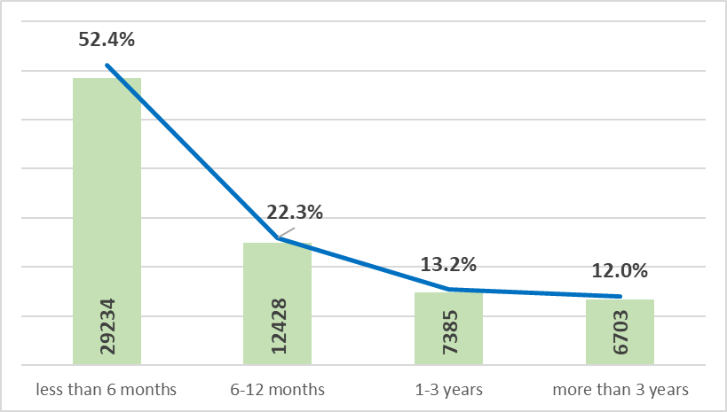

Annex 13: Registered unemployed persons by education level (%) (PES)

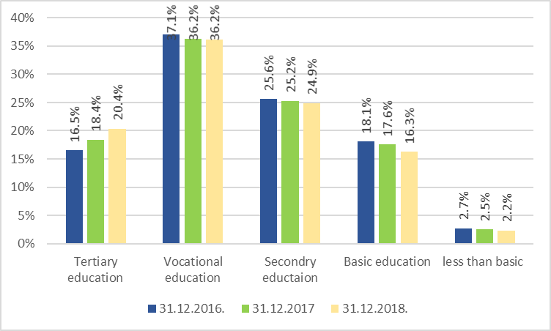

Annex 14. Registered unemployed persons by risk groups at the end period (PES)
Groups of unemployed persons | 2016 | % of the total number | 2017 | % of the total number | 2018 | % of the total number | 31.06.2019 | % of the total number
Long-term unemployed persons (for more than 1 year) | 22 450 | 28,7% | 18 136 | 28,7% | 14 944 | 25,1% | 14 088 | 25,3%
Unemployed young persons in the age group from 15 to 24 years | 6 075 | 7,8% | 4 250 | 6,7% | 3 445 | 5,8% | 2 980 | 5,3%
Disabled unemployed persons | 9 441 | 12,0% | 8 234 | 13% | 8 179 | 13,7% | 8 119 | 14,6%
Unemployed persons aged 50 and older | 29 466 | 37,6% | 24 404 | 38,7% | 24 135 | 40,5% | 22 957 | 41,2%

Annex 15: Main characteristics of registered unemployment (PES)
 | 31.12.2015. | 31.12.2016. | 31.12.2017. | 31.12.2018. | 01.01.2019.-30.06.2019.
Number of registered unemployed at the end of the year | 81 780 | 78 357 | 63 121 | 59 588 | 55 750
Registered unemployment level | 8,7% | 8,4% | 6,8% | 6,4% | 6,0%
Number of persons, who received the status of registered unemployed in the corresponding year (inflow into registered employment) | 104 557 | 102 298 | 87 335 | 87 132 | 42 486
Total number of PES clients (also registered in previous years) | 186 584 | 184 078 | 165 692 | 150 253 | 102 074
Average duration of an unemployment period (days) | 199 | 197 | 194 | 173 | 167
Number of registered vacancies in the corresponding year | 51 343 | 56 328 | 71 342 | 88 492 | 60 013
Number of persons, who found employment in the corresponding year | 69 266 | 72 286 | 67 085 | 63 633 | 33 702
The share of LTU in the total number of registered unemployed | 29,7% | 28,7% | 28,7% | 25,1% | 25,3%
The number of ALMP participants (unique persons) | 99 161 | 113 186 | 105 929 | 91 757 | 44 053

Annex 16: Participation in active labour market policy measures – new entrants (persons) in the corresponding year (PES)
 | 2014 | 2015 | 2016 | 2017 | 2018
Career consultations | 83 493 | 75 874 | 104 081 | 102 522 | 91 050
Measures to Increase Competitiveness (basic competencies) | 41 248 | 29 683 | 29 268 | 26 564 | 22 326
Vocational training, requalification, qualification improvement | 5 123 | 2 787 | 5 316 | 4 650 | 3 435
Non-formal training programmes | 15 457 | 12 328 | 13 738 | 10 876 | 11 848
On-the-job training | 76 | 121 | 178 | 313 | 426
Subsidised employment for the most vulnerable groups of unemployed | 1 315 | 864 | 979 | 870 | 919
Paid temporary public works | 19 204 | 8 430 | 10 934 | 13 030 | 12 918
Entrepreneurship and self-employment | 129 | 157 | 164 | 211 | 213
Youth Guarantee measures | 24 445 | 25 769 | 16 336 | 15 063 | 11 068
Promotion of regional mobility for employed people | 205 | 163 | 161 | 243 | 252
Activation programme for the long term unemployed | - | - | 2 594 | 27 529 | 28 944

https://www.em.gov.lv/en/latvia_in_the_eu/europe_2020_strategy/national_reform_programme_of_latvia/
https://visc.gov.lv/en/professional/standards.shtml
http://www.lbas.lv/projects/esf?locale=en
https://www.cfla.gov.lv/en/eu-funds-2014-2020/general-information
Regulations of the Cabinet of Ministers No.55 “Regulations Regarding Employment of Foreigners”, adopted on 28 January 2014, https://likumi.lv/doc.php?id=264304
Order of the Cabinet of Ministers No. 759 of 9 December 2015, https://likumi.lv/ta/id/278257-ricibas-plans-personu-kuram-nepieciesama-starptautiska-aizsardziba-parvietosanai-un-uznemsanai-latvija.
https://likumi.lv/ta/en/en/id/225425
https://ec.europa.eu/jrc/en/publication/eur-scientific-and-technical-research-reports/vocational-training-and-labour-market-outcomes-evidence-youth-guarantee-latvia
https://www.esfondi.lv/upload/izvertejumi/nosleguma_izvertejums_jauniesu_garantija.pdf
Active Ageing Index project. https://statswiki.unece.org/display/AAI/Active+Ageing+Index+Home
https://www.em.gov.lv/en/economic_development/informative_report_on_medium_and_long_term_labour_market_forecasts/
https://sua.lv/eng/lsua-eng/

